

**COMSATS University Islamabad (Lahore Campus)**



**Assignment <2>– SPRING 2024**

|  |  |  |  |  |  |  |  |
| --- | --- | --- | --- | --- | --- | --- | --- |
| Course Title: | | Game Development |  | Course Code: | CSC495 | Credit Hours: | 3(2,1) |
| Course Instructor/s: | | Saira Aslam |  | Program Name: | BCS/BSE/BCE | | |
| **Due Date:** | | **11:55 pm 20th April 2024** |  | **Maximum Marks:** | | **50** | |
|  | **Important Instructions:**   * Do your Assignment in new Unity Project * **Submit 5 screenshots of your game, a 5 seconds video and cs scripts as in ONE DOC FILE and submit as your registration_number.doc , like FA21-BCS-00.doc** * DO NOT COPY YOUR WORK FROM ANY SOURCE * Submit your Assignment at Google Classroom Assignment 2 folder * **MAKE THIS ASSIGNMENT IN A GROUP OF TWO STUDENTS** | | | | | | |

**Question Marks: 50**

***CLO: <2>; Bloom Taxonomy Level: <Creating>***

1. Group member 1 Reg # _FA21-BSE-133_____________________________________
2. Group member 2 Reg # __ FA21-BSE-127____________________________________

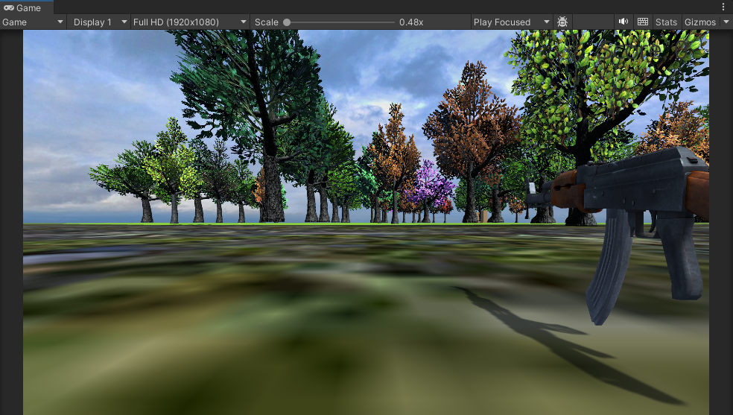

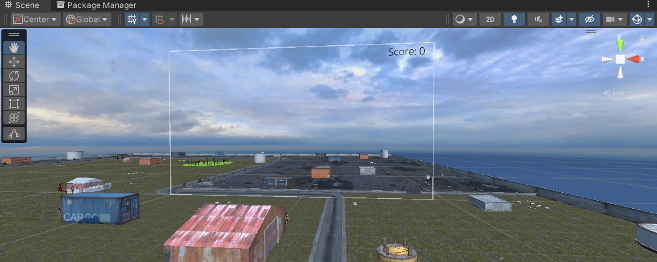

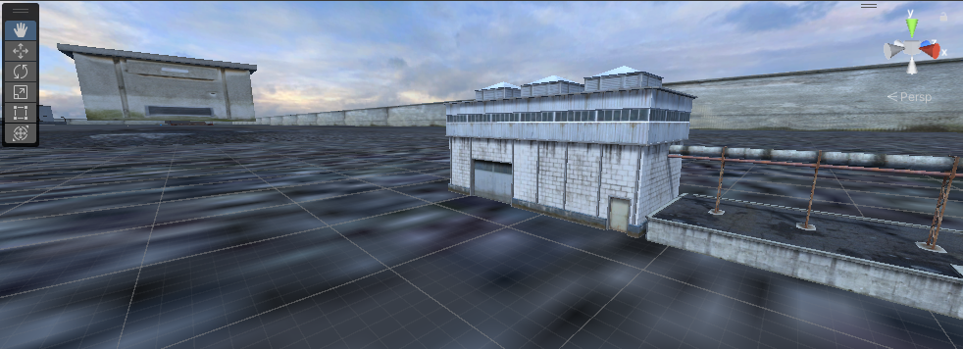

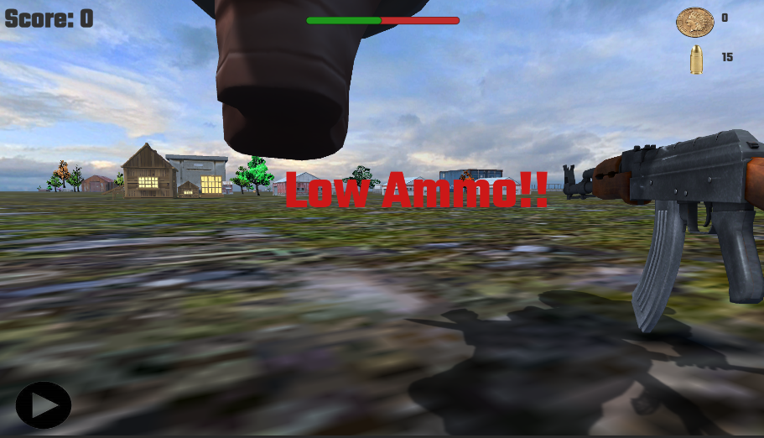

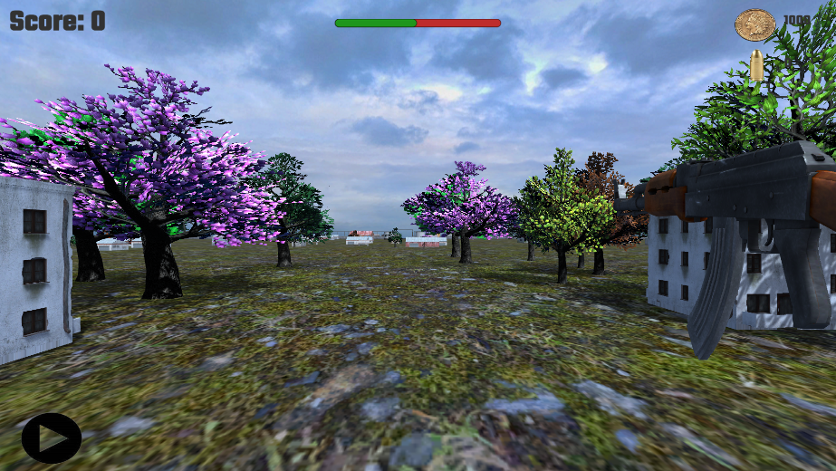

**playerScript:**

using System.Collections;

using System.Collections.Generic;

using UnityEngine;

using UnityEngine.UI;

public class playerScript : MonoBehaviour

{

    public GameObject gameOverPanel,gameWinPanel;

    public Text coinText,bulletText,scoreText;

    public float score=0;

    public float numOfBullets=100;

    public float numOfCoins=0;

    public Text flashingText;

    public float TotalBlinkDuration=8f,BlinkTime=0.5f;

    public Slider slider;

    bool isCheckPointReached = false;

    // Start is called before the first frame update

    void Start()

    {

        gameOverPanel.SetActive(false);

        gameWinPanel.SetActive(false);

        coinText.text = numOfCoins.ToString();

        bulletText.text = numOfBullets.ToString();

        scoreText.text = "Score: "+score.ToString();

    }

    // Update is called once per frame

    void Update()

    {

        if(Input.GetMouseButtonDown(0))

        {

            numOfBullets--;

            bulletText.text = numOfBullets.ToString();

        }

        if(numOfBullets<=0)

        {

            Time.timeScale = 0;

            gameOverPanel.SetActive(true);

        }

        if(numOfBullets <= 15 && numOfBullets >= 10)

        {

            StartCoroutine(BlinkText("Low Ammo!!"));

        }

    }

    public void OnCollisionEnter(Collision col)

    {

        //If 2nd check-point reached, the user WIN

        if (col.gameObject.name.StartsWith("WinningBoundary_1") && isCheckPointReached)

        {

            Time.timeScale = 0;

            gameWinPanel.SetActive(true);

        }

        //If 1st check-point reached, increase coins and bullet

        if (col.gameObject.name.StartsWith("WinningBoundary") && !isCheckPointReached)

        {

            numOfCoins += 50;

            numOfBullets += 30;

            score += 10;

            coinText.text = numOfCoins.ToString();

            bulletText.text = numOfBullets.ToString();

            scoreText.text = "Score: "+score.ToString();

            slider.value = numOfBullets;

            isCheckPointReached = true;

        }

        if(col.gameObject.CompareTag("enemy"))

        {

            Destroy(col.gameObject);

            // Instantiate(col.gameObject,new Vector3(Random.Range(1,100),0,Random.Range(1,100)), Quaternion.identity);

            // enemyScript enemy = col.gameObject.transform.GetComponent<enemyScript>();

            // if(enemy != null)

            // {

            //     enemy.die();

            // }

        }

    }

IEnumerator BlinkText(string textToBlink)

{

    float elapsedTime = 0f;

    while (elapsedTime < TotalBlinkDuration)

    {

        flashingText.text = textToBlink;

        yield return new WaitForSeconds(BlinkTime);

        flashingText.text = string.Empty;

        yield return new WaitForSeconds(BlinkTime);

        elapsedTime += 2 * BlinkTime;

    }

    // Ensure the text is not visible for entire game

    flashingText.text = "";

}

public void bulletStriked(){

    score += 10;

    scoreText.text = "Score: "+score.ToString();

}

}

**enemyScript.cs**

using System.Collections;

using System.Collections.Generic;

using UnityEngine;

public class enemyScript : MonoBehaviour

{

    public GameObject fps;

    public GameObject player;

    private playerScript script; // Corrected to private to ensure it's accessible within the class

    private Animator _anim; // Corrected to private to ensure it's accessible within the class

    // Start is called before the first frame update

    void Start()

    {

        script = player.GetComponent<playerScript>(); // Assign to the class-level variable

        if(!script)

        {

            print("not set!!");

        }

        _anim = GetComponent<Animator>();

    }

    // Update is called once per frame

    void Update()

    {

        transform.LookAt(fps.transform);

    }

    public void die()

    {

        _anim.SetTrigger("die");

    }

    public void OnCollisionEnter(Collision col)

    {

        if(col.gameObject.CompareTag("bullet"))

        {

            script.bulletStriked();

            die();

        }

    }

}

**uiManager.cs**

using System.Collections;

using System.Collections.Generic;

using UnityEngine;

using UnityEngine.UI;

using UnityEngine.SceneManagement;

public class uiManager : MonoBehaviour

{

    public GameObject button;

    public Sprite playSprite,pauseSprite;

    Image _spriteRef;

    public void Start()

    {

        _spriteRef = button.GetComponent<Image>();

        Time.timeScale = 1;

    }

    public void PlayAgain()

    {

        SceneManager.LoadScene(0);

    }

    public void PlayGame()

    {

        print("clicked!!");

        if(Time.timeScale == 1)

        {

            Time.timeScale = 0;

            _spriteRef.sprite = pauseSprite;

        }

        else{

            Time.timeScale = 1;

            _spriteRef.sprite = playSprite;

        }

    }

}

**bulletController.cs**

using System.Collections;

using System.Collections.Generic;

using UnityEngine;

public class bulletController : MonoBehaviour

{

    public GameObject bullet;

    // Update is called once per frame

    void Update()

    {

        if(Input.GetMouseButtonDown(0))

        {

            Instantiate(bullet,transform.position, transform.rotation);

        }

    }

}